**Hands On Session**

**Hello World RESTful Web Service**

This is a simple Spring Boot REST application that provides a "Hello World" endpoint.

**Project Structure**

src/

├── main/

│   ├── java/

│   │   └── com/

│   │       └── cognizant/

│   │           └── springlearn/

│   │               ├── SpringLearnApplication.java

│   │               └── controller/

│   │                   └── HelloController.java

│   └── resources/

│       └── application.properties

```

**## Requirements**

- Java 11 or higher

- Maven 3.6 or higher

**## Building the Project**

To build the project, run:

```bash

mvn clean package

```

**## Running the Application**

To run the application, use one of the following methods:

### Method 1: Using Maven

```bash

mvn spring-boot:run

```

### Method 2: Using Java JAR

```bash

java -jar target/spring-learn-1.0.0.jar

```

**## Testing the Application**

Once the application is running, you can test it using:

**### 1. Web Browser**

Open your browser and navigate to:

```

http://localhost:8083/hello

```

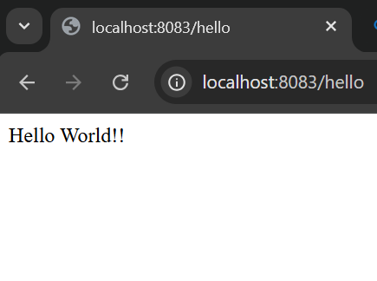

**### 2. Postman**

- Open Postman

- Create a new GET request

- Set the URL to: `http://localhost:8083/hello`

- Send the request

## Expected Response

The endpoint should return:

```

Hello World!!

```

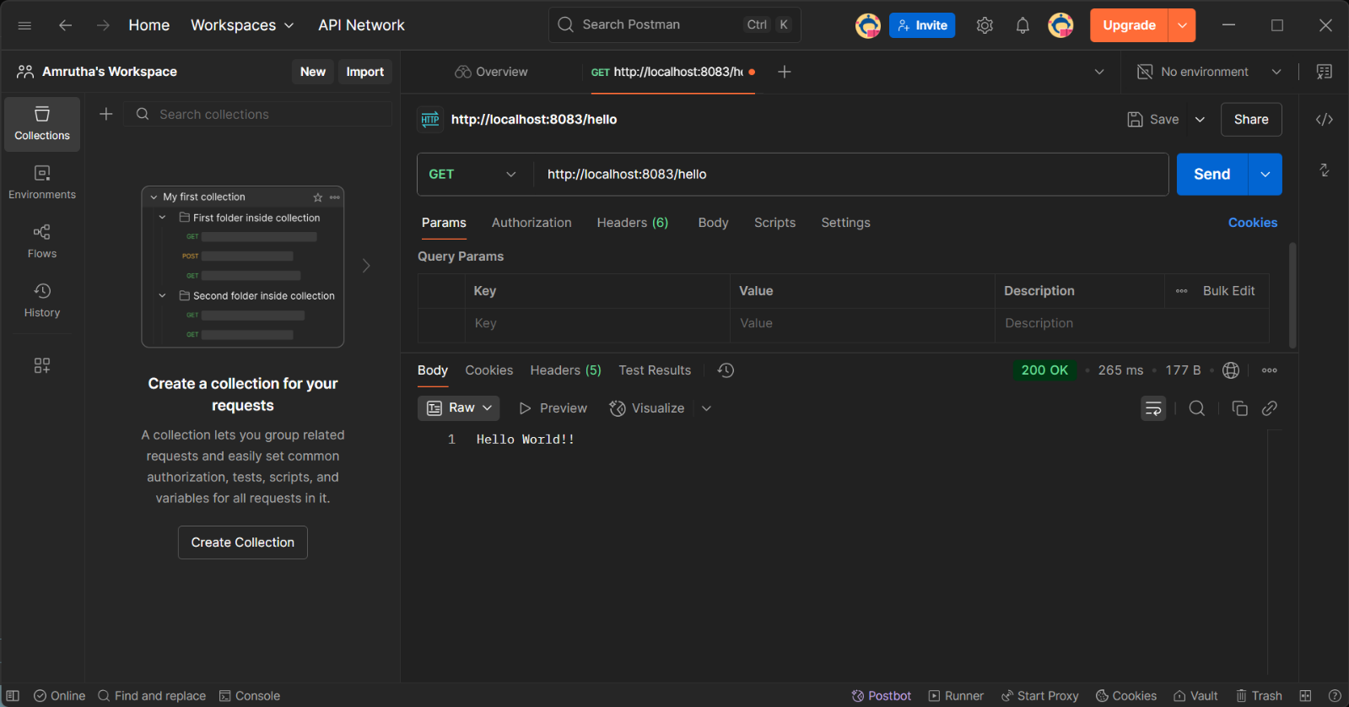

## HTTP Headers

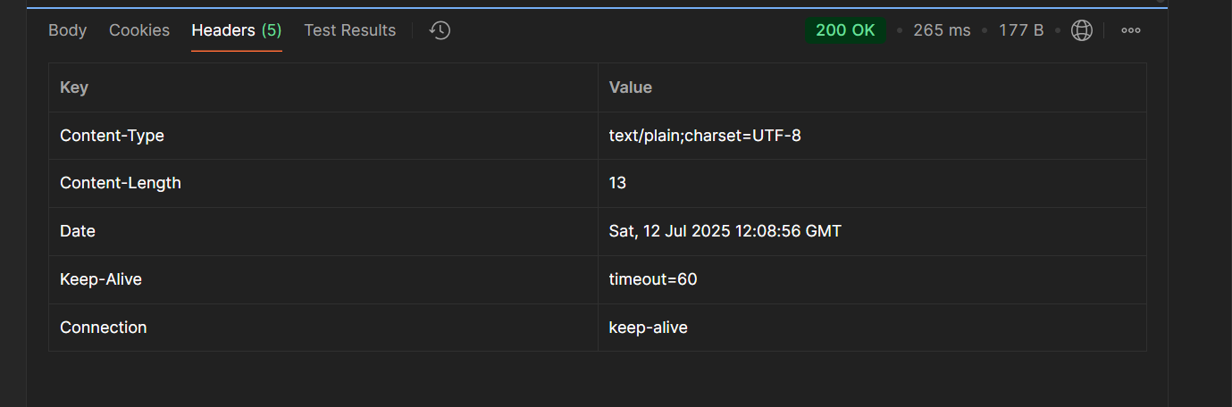

When testing with Postman or browser developer tools, you can view the HTTP headers

**## Logging**

The application includes logging in the `sayHello()` method:

- START log when the method begins

- END log when the method completes

**## API Details**

- **Method**: GET

- **URL**: `/hello`

- **Controller**: `com.cognizant.springlearn.controller.HelloController`

- **Method**: `sayHello()`

- **Response**: "Hello World!!"